

|  |
| --- |
| BATTLE OF TWO CITIES |
|  |
| October 25  [GEOSPATIAL ANALYSIS]  Authored by: AKSHAT SAXENA |

# ****DESCRIPTION OF THE PROBLEM:****

|  |
| --- |
| Delhi and Bangalore are two of the major metropolitan cities in India.  They are vibrant and multi-cultural.  In this project I will be diving deep into their neighborhoods and find the similarities and dissimilarities between them on the basis of food. |
| *“BANGALORE VS DELHI”* |
| ****DISCUSSION OF THE BACKGROOUND:**** The people of these cities have been on each other's necks for decades to prove that they are superior in culture to the other. In this project I wil**l** settle this debate once and for all on the basis of the most important aspect of them all: FOOD  The similarity and dissimilarity will be decided on the basis of their goods. There can be one of the following conditions:  The food in Delhi is completely similar to the food in Bangalore.  The variety of food in Delhi is a subset of the variety of food in Bangalore.  The variety of food in Mumbai is a **subset** of the variety of food in Bangalore. |

# WHO IS THIS PROJECT FOR:

This project is suitable for anyone who is a foodie and wants to shift residence to either of these cities. This project provides a solution to all of their problems.

# DESCRIPTION OF THE DATA:

For any “data science project” data is of paramount importance. For this study, we needed data about neighbourhoods in each of these metro cities In this study, we will download the CSV, read it into a pandas Data frame and curate it to remove the data related to all other cities, towns, and places which are not Bangalore or Delhi, since we are only interested in comparing these two biggest metro cities in India. We shall then clean up the unnecessary columns in the CSV, which is not relevant or useful for our current study. Post office names (office name) will be used as the neighbourhood names in each of the regions such as Bangalore or Delhi. Neighbourhood names with the same pin code will be combined as a single row. Foursquare API will be used to find the longitude and latitude of each of the neighbourhoods in both Bangalore and Delhi. This will form the dataset we will use for this study. Also, I'll use this data about various restaurants in Delhi which I found on Kaggle: <https://www.kaggle.com/shaswatd673/delhi-neighborhood-data> Also,I found the Bangalore data here: <https://www.kaggle.com/rmenon1998/bangalore-neighborhoods>

# THE DATASETS:

DELHI:

The Delhi Dataset was readily available to me on Kaggle so there was not much cleaning needing the heads of the two csv files looked like this (after cleaning):

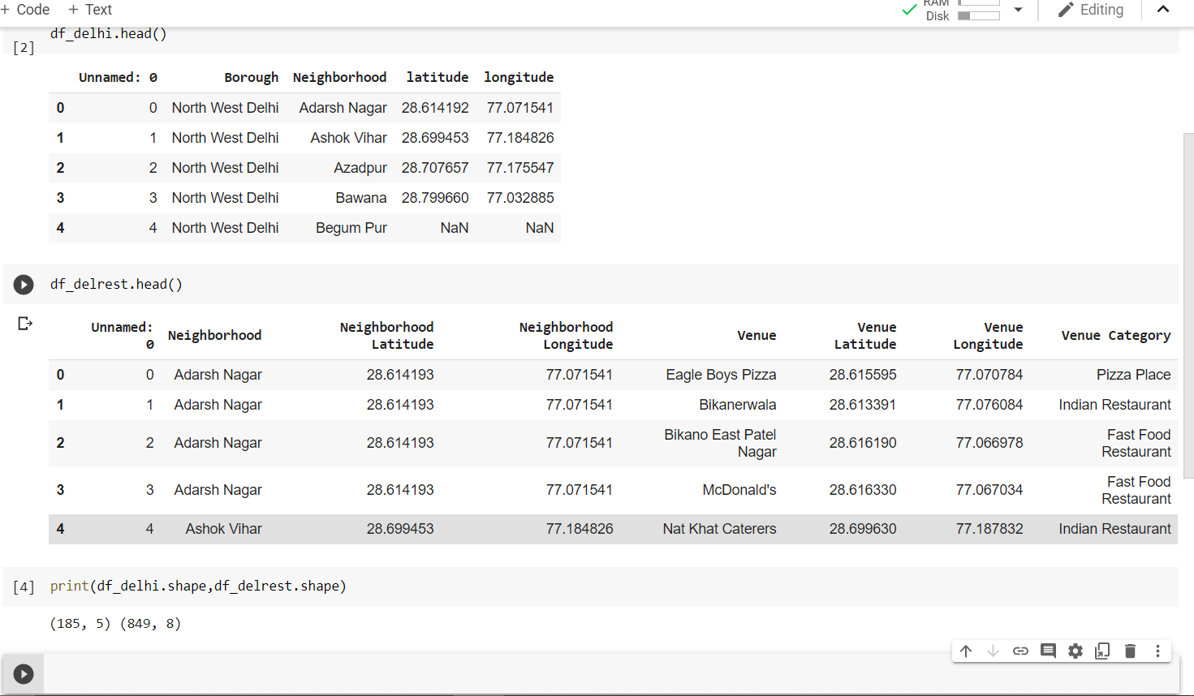

## BANGALORE:

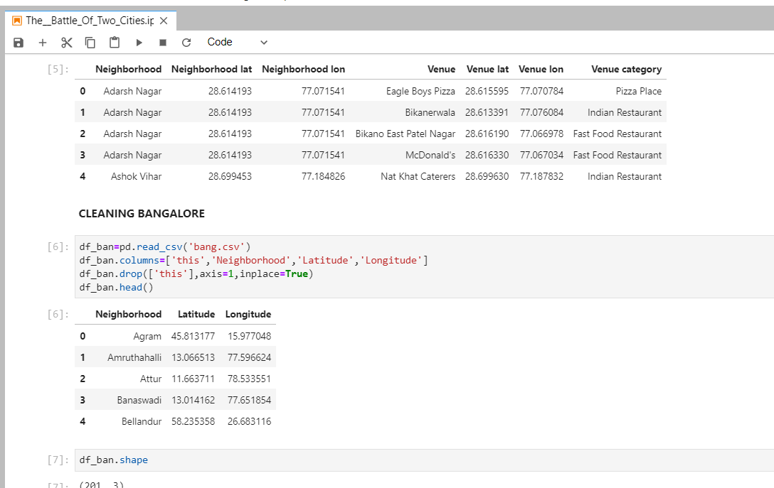

# ANALYSING THE NEIGHBORHOODS OF THE TWO CITIES:

## **Finding top venues near Bangalore neighborhoods**

We will use the Foursquare API to find the top venues in the neighbourhoods of Bangalore. This will help us understand the nature of life Bangalore neighbourhoods have to offer. We will iteratively make Foursquare API calls for each of the Bangalore neighbourhoods in our dataset.

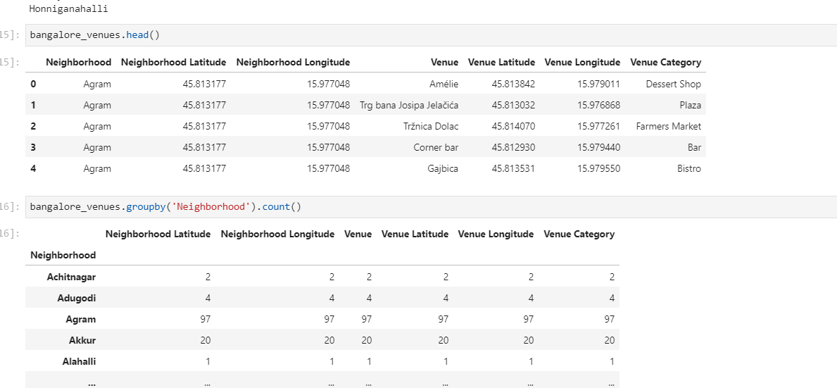

# Finding top venues near Delhi neighborhoods:

# 

# Cluster the neighborhoods based on the similarity of top common venues:

Given that we now have the required information regarding the top venues against each of the neighborhoods, let us now apply a clustering algorithm to group the neighborhoods based on the similarity in types of venues they have. By clustering, we also provide information to users on a common type of neighborhoods. We will use the k-Means clustering approach to cluster the neighborhoods. k will be selected as 5. This means that we will group the neighborhoods into 5 clusters. Each of the neighborhoods gets a Cluster Label assigned.

We will then use the dataset with cluster labels assigned to visualize the clusters in a folium map.

## DELHI:

# 

## BANGALORE:

# RESULTS:

# BANGALORE:

EXAMINING DIFFERENT CLUSTERS OF BANGALORE:

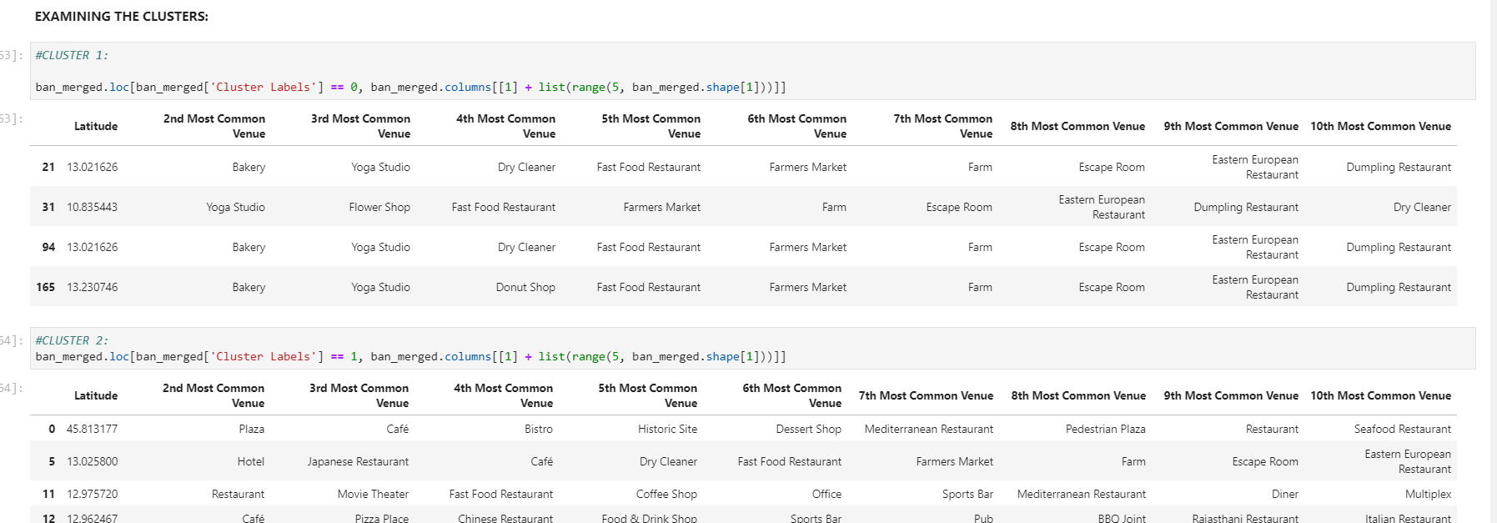

FROM IMAGE WE CAN INFER THAT THE MOST COMMON PLACES IN THESE CLUSTERS ARE: BAKERY, YOGA STUDIO, CAFÉ, RESTAURANT(NORMAL).

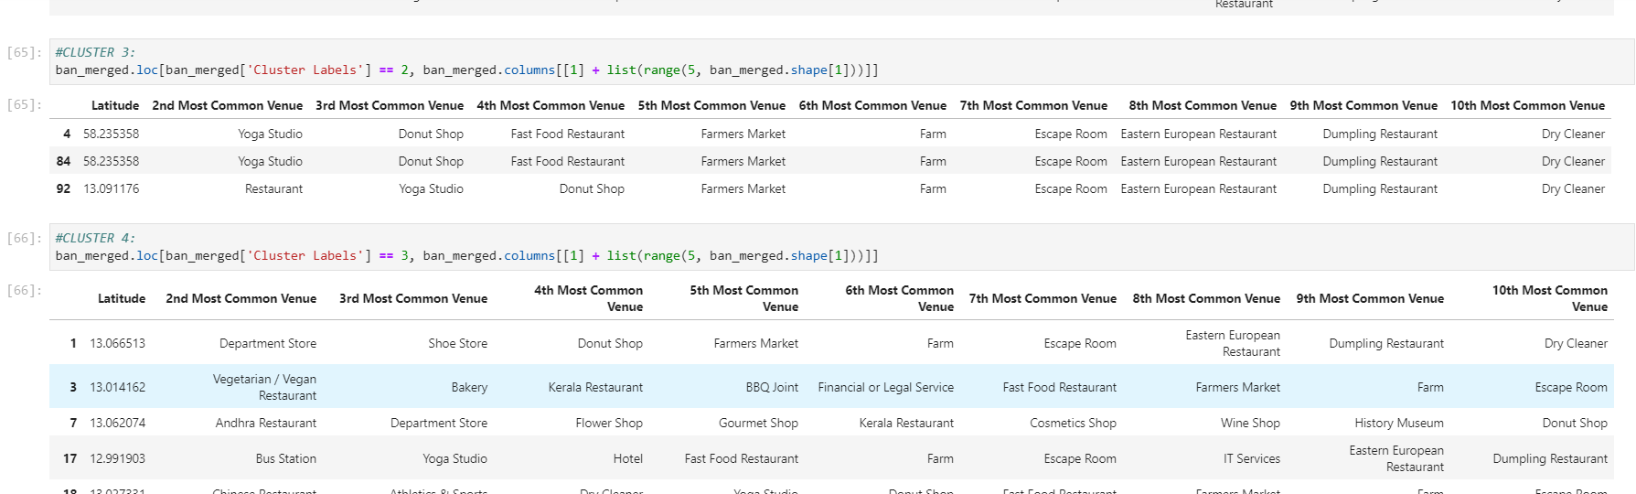

FROM IMAGE WE CAN INFER THAT THE MOST COMMON PLACES IN THESE CLUSTERS ARE: YOGA STUDIO, RESTAURANT, DEPARTMENTAL STORE, ETC.

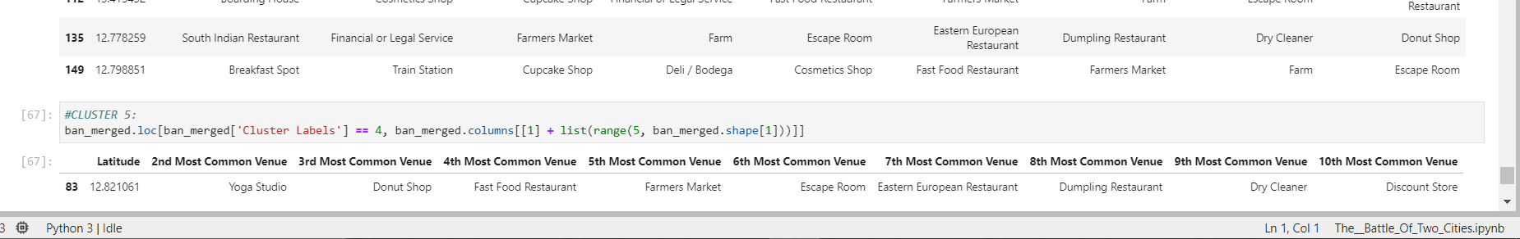

FROM IMAGE WE CAN INFER THAT THE MOST COMMON PLACES IN THESE CLUSTERS ARE: YOGA STUDIO, DONUT SHOP AND RESTAURANT (SOTH INDIAN).

THUS, FROM THE CLUSTERS WE SEE THAT BANGALORE DOES NOT HAVE A WIDE VARIETY OF FOODIE-CULTURE AND MAINLY HAS CAFÉS AND BREAKFAST SPOTS. THIS IS BECAUSE IT IS THE TECHNICAL HUB OF INDIA AND MAINLY COONSISTS OF OFFICES OF MAJOR TECH COMPANIES.

## NOW WE’LL DO THE SAME FOR DELHI:

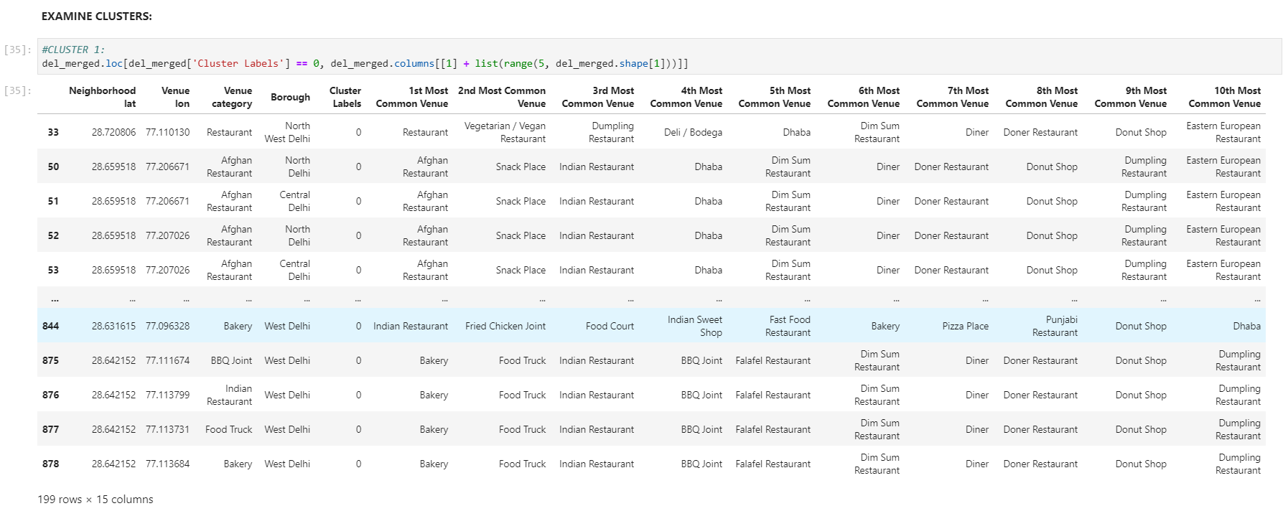

FROM IMAGE WE CAN INFER THAT THE MOST COMMON PLACES IN THESE CLUSTERS ARE: AFGHAN RESTAURANT (HOME TO A CONSIDERABLE NUMBER OF REFUGEES), BAKERY, NORMAL RESTAURANT.

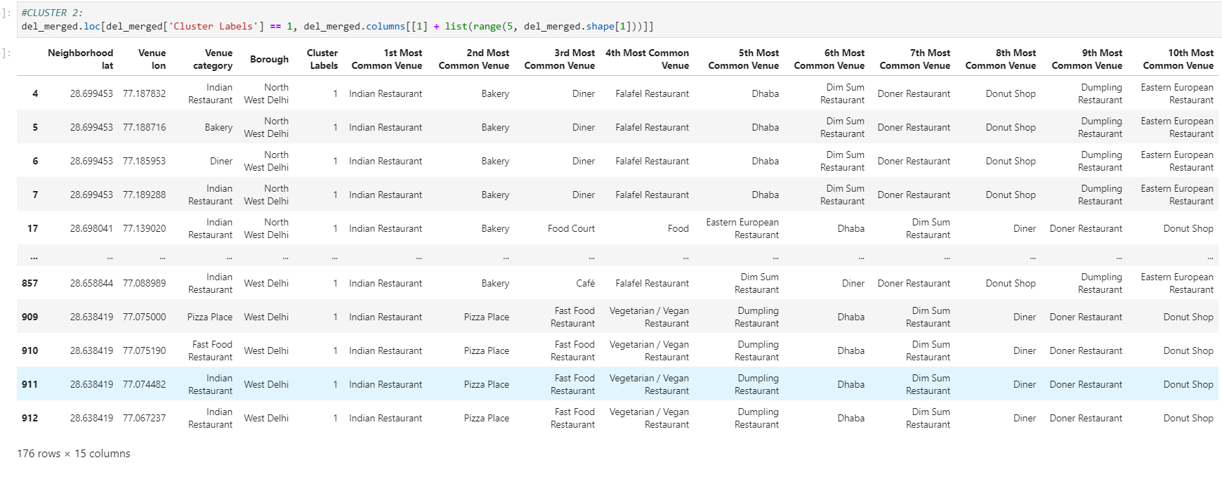

FROM IMAGE WE CAN INFER THAT THE MOST COMMON PLACES IN THESE CLUSTERS ARE: NORMAL INDIAN RESTAURANTS

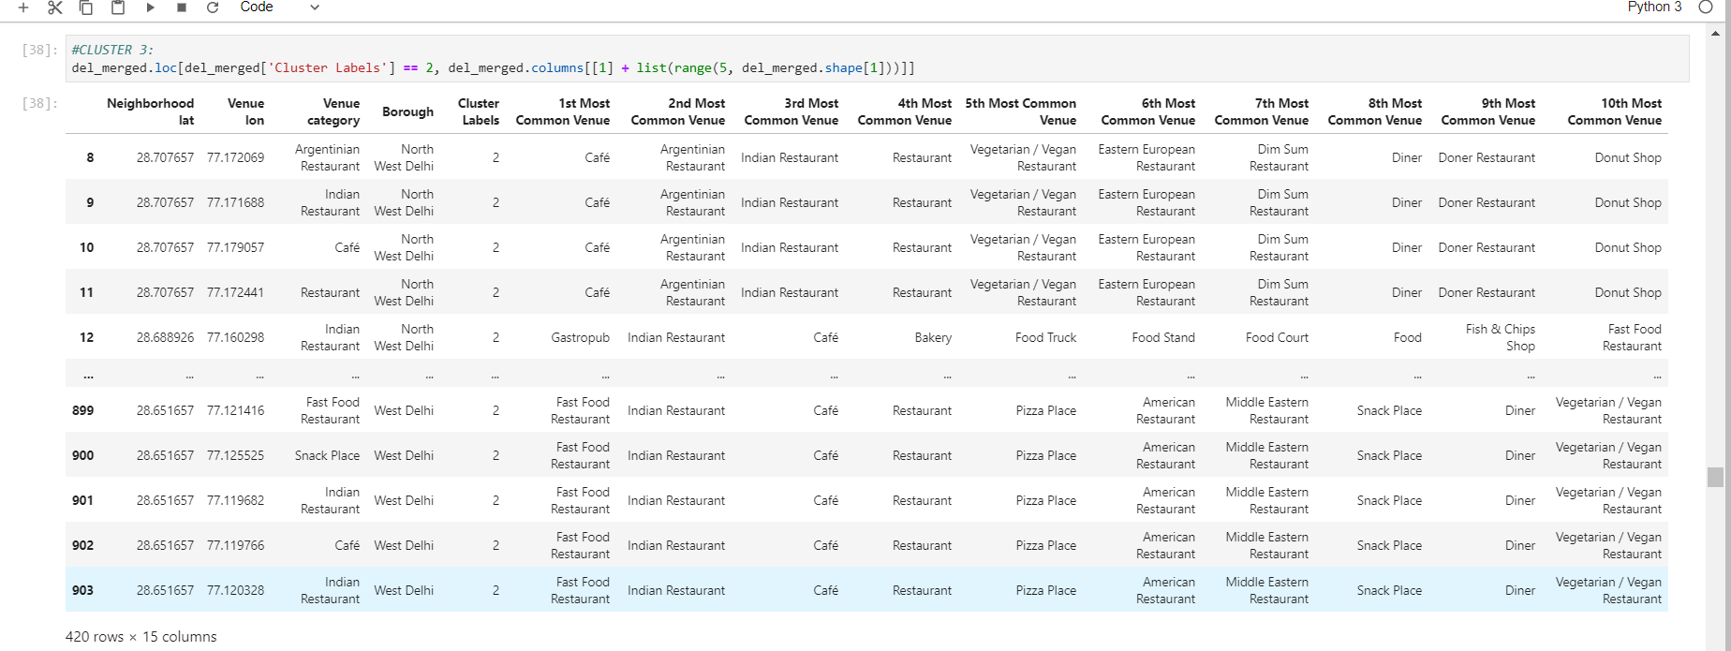

FROM IMAGE WE CAN INFER THAT THE MOST COMMON PLACES IN THESE CLUSTERS ARE: CAFÉ AND FAST-FOOD JOINTS AND ALSO EASTERN EUROPEAN AND VEGAN RESTAURANTS.

CLEARLY, DELHI SEEMS VICTORIOUS!

# DISCUSSION SECTION:

THUS, WE CAN SEE THAT BANGALORE IS SUITABLE FOR PEOPLE WHO DON’T HAVE A FOOD INCLINATION AND ARE NORMAL OFFICE-GOERS.

WHEREAS, IF YOU ARE A FOODIE AND WOULD LIKE TO TASTE DIFFERENT CUISINES , DELHI IS THE PLACE FOR YOU.

# CONCLUSION:

In this project, we have attempted to load the dataset for two of India’s prime metro cities and have tried to analyse the neighbourhood regions in these metro cities based on the type of popular and top venues they have. We have clustered the neighbourhoods based on the most common top venues in each of the neighbourhood. Our intention with this project was to analyse and understand the difference in the type of life in these metros, which can offer decision points for anybody who is considering to settle in either of the metro cities and can get a peek into what type of experience and facilities he will be provided with.

*“DELHI WINS THE BATTLE OF TWO CITIES!”*